PROJECT EXPO-26
PHASE 2: Ideation & Concept Development

SECURE MOBILE WEB-BASED REMOTE VOTING SYSTEM

Team Members: Vaishika T.A, Ezhilvizhi R,
Sowmiya A, Babykarthika S

BRAINSTORMING REPORT:
Problem Statement
To develop a basic remote web-based voting system that allows eligible users to cast their vote through a simple and user-friendly webpage while providing basic authentication, vote submission and confirmation.
Ideas Generated:
- User Login – Allow voters to access the voting page using basic login credentials.
- One-Time Voting Restriction – Prevent a user from submitting more than one vote.
- Candidate Display – Display the available candidates and their basic information.
- Vote Selection & Submission – Allow the user to select a candidate and submit their vote.
- Vote Confirmation – Display a confirmation message after successful vote submission.
- Basic Database Storage – Store required voting information in a database when backend functionality is implemented.
- Simple Admin/Results View – Provide a basic view for managing or displaying voting results, if included in the prototype.
- Responsive User Interface – Design the webpage to work reasonably well on both mobile and desktop screens.
- Input Validation – Check basic user inputs and display appropriate error messages.
10.Simple Session Management – Manage the user's login session and prevent unauthorized access to the voting page.
Proposed Technology Stack
Frontend: HTML, CSS, JavaScript
Backend: A suitable beginner-friendly backend technology
Database: MySQL

Idea Prioritization Matrix :

Idea | IMPACT | FEASIBILITY | PRIORITY
User Login | HIGH | HIGH | P1
Candidate Display | HIGH | HIGH | P1
One-Time Voting Restriction | HIGH | MEDIUM | P1
Vote selection & submission | HIGH | HIGH | P1
Vote Confirmation Message | HIGH | HIGH | P1
Basic Database Storage | HIGH | MEDIUM | P2
Basic Results | MEDIUM | MEDIUM | P2
Responsive UI | MEDIUM | HIGH | P2
Input Validation | MEDIUM | HIGH | P2
Simple Session Management | MEDIUM | MEDIUM | P3

Empathy map:

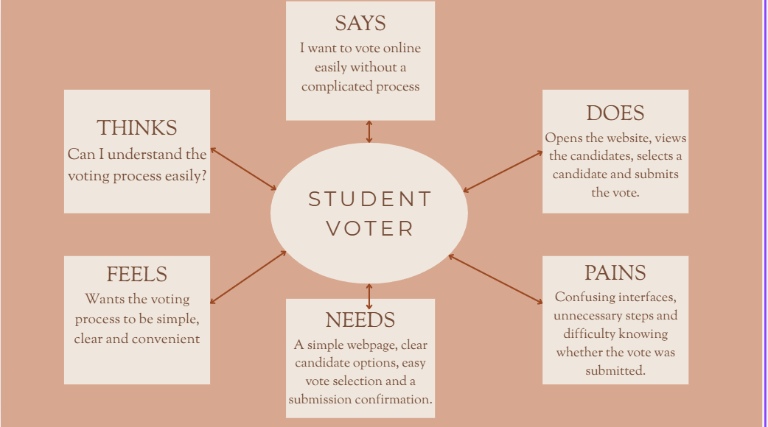

USER PERSONA:
Field | details
Name | Ananya
Age | 19
Role | College Student / Voter
Technical Level | Basic knowledge of websites and mobile applications
Goal
  To cast a vote quickly and easily from anywhere
Needs | Simple interface, clear candidate information, easy voting process and confirmation
Frustrations | Complicated procedures, unnecessary steps and uncertainty about whether the vote was submitted
Expectations | A simple, understandable and convenient voting webpage

PROPOSED SOLUTION:
The proposed solution is to create a secure webpage to cast the vote without any worries. In that webpage , we can easily cast the votes without any delay. Our proposed solution help the voters to be in a calm state throughout the whole day during elections. Our solution helps the voters to do the voting in a much easier way than they expect. Our main idea is to create a simple web page for voting where the user can easily login and find the candidates who are all participating in election and then choose the appropriate candidate based on their wish and then confirm the vote. Once they confirmed the vote, a simple message will be shown to them. These project will mainly help the remote users.

Main features:
Login: It allows the student/user to login easily with their register no or id.
Candidates list: Here, we will list all the Eligible candidates who are all appearing for the particular election.
Candidate Selection: The user/student can choose the candidates based on their wish.
Vote Submission: After choosing the candidate, they can submit their vote by clicking the submit button.
Confirmation: Once the voter confirmed the vote, a confirmation message, *Your vote was successfully registered* will be displayed.

FUNCTIONAL REQUIREMENTS:
FR-1:UserLogin
The system shall allow registered users to log in using their required credentials.
FR-2:CandidateDisplay
The system shall display the available candidates with their basic information.
FR-3:CandidateSelection
The user shall be able to select one candidate before submitting the vote.
FR-4:VoteSubmission
The system shall allow the user to submit the selected vote.
FR-5:One-TimeVoting
The system shall prevent a user from submitting more than one vote, if user accounts/database functionality is implemented.
FR-6:VoteConfirmation
The system shall display a confirmation message after successful vote submission.
FR-7:ResultsDisplay
The system shall provide a basic results/tally view where applicable.

NON-FUNCTIONAL REQUIREMENTS:
NFR-1:Usability
The webpage should have a simple and understandable interface.
NFR-2:Responsiveness
The webpage should work properly on both mobile and desktop screen sizes.
NFR-3:Performance
The main pages should load within a reasonable time under normal project-demo conditions.
NFR-4:Reliability
The system should correctly process valid user actions and display appropriate error messages when invalid input is provided.
NFR-5:Security
Basic user authentication, input validation and access control should be considered to prevent unauthorized access.
NFR-6:Maintainability
HTML, CSS, JavaScript and backend code should be organized into separate files/modules wherever applicable, making the project easier to modify and maintain.

Project | planning:

Week 1 – Planning & Design | Finalize the basic voting features, prepare the user flow and create simple webpage wireframes.
Week 2 – Webpage Development | Create the basic webpage structure, login page and candidate display page using HTML/CSS.
Week 3 – Voting Process | Implement candidate selection, vote submission and confirmation page. Connect the required backend/database if included in the prototype.
Week 4 – Integration & Testing | Connect the pages, test the voting flow, check form inputs and verify that the basic system works correctly.
Week 5 – Finalization & Demo | Fix errors, improve the interface, prepare documentation and demonstrate the completed prototype

RISK ANALYSIS:
- Incorrect Vote Submission
- Risk: The user may select the wrong candidate or the selection may not be registered correctly.
Mitigation: Provide a clear candidate-selection interface and a confirmation step before/after submission.
2. Duplicate Vote
Risk: A user may try to submit the vote more than once.
Mitigation: Add a basic one-vote-per-user check if login/database functionality is implemented.
3. Login/Input Errors
Risk: Incorrect or incomplete user information may prevent the user from accessing the voting page.
Mitigation: Use basic input validation and clear error messages.
4. Website/Technical Errors
Risk: Buttons, pages, forms or links may not work properly.
Mitigation: Test every page and the complete voting flow before the final demo.
5. Data Loss
Risk: Voting information may be lost if the database or storage is not handled properly.
Mitigation: Keep a backup of the project/database and test data storage before demonstration.
6. Time Constraint
Risk: The team may not complete all planned features within the project period.
Mitigation: Prioritize the core features first and keep additional features optional.
7. Poor User Experience
Risk: Users may find the webpage confusing or difficult to navigate.
Mitigation: Keep the interface simple, use clear buttons/labels and test it with a few users.

